Jeff Austin, III

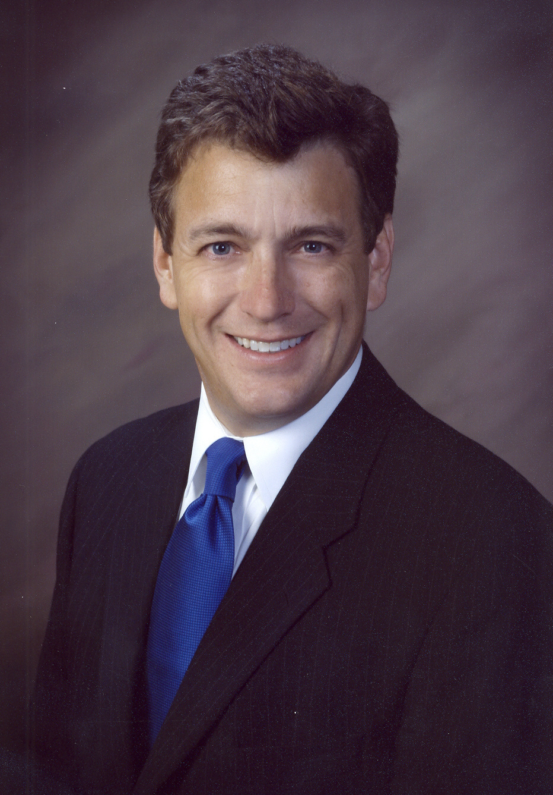
Jeff Austin, III is a seventh generation Texan and a fourth generation banker. He currently is Vice Chairman of the Board of Austin Bank Texas, N.A. and Austin Bancorp. He previously served as President and CEO of affiliate bank First State Bank, Frankston, which has recently merged into Austin Bank Texas, N.A. He serves on the Board of Directors for affiliate banks First State Bank, Athens and Capital Bank, Houston.

Jeff earned his MBA and BS degrees from the University of Texas at Tyler. He is a graduate of the Harvard Business School Advanced Management Program, Southwestern Graduate School of Banking at SMU, and Banking Leadership Texas.

In October, 2011, Jeff was appointed by Governor Rick Perry as Commissioner of the Texas Transportation Commission and was reappointed in April, 2013 for a six-year. In February 2005, he was first appointed Chairman of the newly formed North East Texas Regional Mobility Authority (NET RMA) by Governor Perry. He was reappointed in May 2006, February 2008, and March 2010.

Jeff is involved with the Texas Bankers’ Association (TBA) serving as Chairman in 2010-2011. He has also served as Chairman of the Government Relations Council and was the 2008-2009 Treasurer, among other roles. In May 2007, he was honored with the TBA’s Chairmans Award. He is also a member of the American Bankers Association’s Government Relations Committee and is a Texas co-coordinator for Grassroots activities.

Jeff’s involvement in his community includes serving as Past Chairman of the Tyler Area Chamber of Commerce (honored in 2001 as the Volunteer of the Year), the Development Board and Audit Committee of the UT Health Science Center in Tyler, an Advisory Director for the Texas Rose Festival Association, Board member of the Bob Bullock Texas State History Museum and Past President of the East Texas Symphony Orchestra.

As a former Scout, Scoutmaster and District Chairman, Jeff is a Board member and a Past President of the East Texas Area Council of Boy Scouts which covers 17 East Texas Counties and remains active with Troop 369 in Tyler. He is Wood Badge trained and has served on staff at the BSA National Jamboree.

